Experiment No. 1

- Experiment Title: Demonstrate Inline,Internal,External JavaScript, use console methods; create a webpage showing user info and a welcome message.
- Software/Tools Required: VS Code, Html/JS Compiler…
- Experiment Program Code:
Internal:
<!DOCTYPE html>
<html>
<head>
<title>Hello World</title>

<style>
body{
background-color:#ffe4e1;
text-align:center;
font-family:Arial, sans-serif;
padding:40px;
}

h1{
font-size:48px;
color:white;
background-color:#91ff00;
padding:15px;
border-radius:8px;
}

p{
font-size:20px;
color:#333333;
background-color:#ffffcc;
padding:10px;
margin-top:20px;
}

button{
font-size:18px;
color:white;
background-color:green;
padding:12px 24px;
border:none;
border-radius:5px;
cursor:pointer;
margin-top:20px;
}
</style>

</head>
<body>

<h1>Hello World</h1>
<p>Name : Aaryan K. Kawale , PRN : 24070521162</p>

<p>This is a sample Webpage made using External css.</p>

<button>Click Me</button>

</body>
</html>

External:
<!DOCTYPE html>
<html>
<head>
<title>Hello World</title>
<link rel="stylesheet" href="style.css">
</head>
<body>

<h1>Hello World</h1>
<p> Name : Aaryan Kawale , PRN: 24070521162</p>
<p> Sec: C, Sem: 5th </p>

<p>This is a sample Webpage is made by using the External CSS.</p>

<button>Click Me</button>

</body>
</html>

Inline:
<!DOCTYPE html>
<html>
<head>
<title>Hello World</title>
</head>
<body style="background-color:#f0f8ff; text-align:center; font-family:Arial, sans-serif; padding:40px;">

<h1 style="font-size:48px; color:white; background-color:#007BFF; padding:15px; border-radius:8px;">
Hello World
</h1>
<p>
Name : Aaryan K. Kawale ,PRN : 24070521162
</p>
<p style="font-size:20px; color:#333333; background-color:#ffffcc; padding:10px; margin-top:20px;">

This is a sample webpage designed by Inline CSS.
</p>

<button style="font-size:18px; color:white; background-color:green; padding:12px 24px; border:none; border-radius:5px; cursor:pointer; margin-top:20px;">
Click Me
</button>
</body>
</html>
- Output:
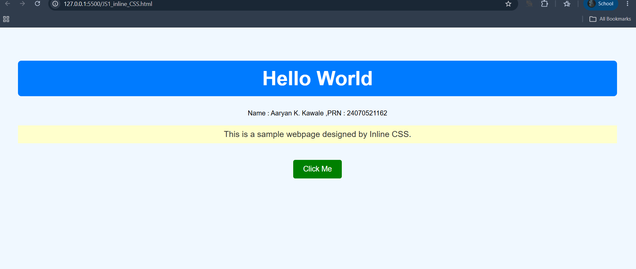
Inline:

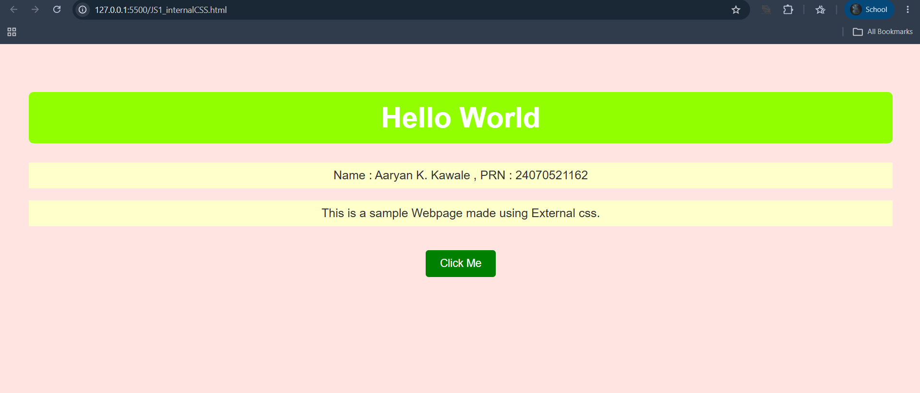
External:

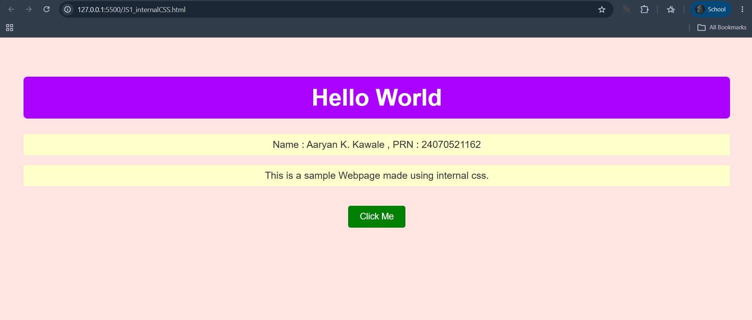
Internal:

Case Study 1
- Case Study Title: Desing a webpage for SIT Nagpur with buttons , text , images, etc…
- Case Study Program Code:
- <!DOCTYPE html>
- <html lang="en">
- <head>
- <meta charset="UTF-8">
- <meta name="viewport" content="width=device-width, initial-scale=1.0">
- <title>SIT Nagpur - Computer Science Department</title>
- <style>
- body {
- font-family: Arial, sans-serif;
- margin: 0;
- padding: 0;
- /* Live campus background image */
- background-image: url('https://d3lzcn6mbbadaf.cloudfront.net/media/details/ANI-20230411114128.jpg');
- background-size: cover;
- background-position: center;
- background-attachment: fixed;
- background-repeat: no-repeat;
- }
- header {
- background-color: #ae1717b8; /* Symbiosis Maroon */
- color: white;
- padding: 20px;
- text-align: center;
- }
- .logo {
- max-width: 180px;
- height: auto;
- margin-bottom: 10px;
- background-color: transparent;
- }
- nav {
- background-color: #333;
- overflow: hidden;
- }
- nav a {
- float: left;
- display: block;
- color: white;
- text-align: center;
- padding: 14px 20px;
- text-decoration: none;
- }
- nav a:hover {
- background-color: #ddd;
- color: black;
- }

- /* Flexbox wrapper to place sections side by side */
- .content-wrapper {
- display: flex;
- flex-direction: row;
- justify-content: center;
- align-items: stretch;
- gap: 30px;
- max-width: 1200px;
- margin: 50px auto 100px auto;
- padding: 0 20px;
- }

- /* Shared stylings for both white info blocks */
- .info-box {
- flex: 1;
- padding: 30px;
- background: rgba(255, 255, 255, 0.92);
- border-radius: 8px;
- box-shadow: 0 4px 15px rgba(0,0,0,0.3);
- }

- h2, h3 {
- color: #333;
- }
- ul {
- padding-left: 20px;
- line-height: 1.6;
- }
- li {
- margin-bottom: 8px;
- }

- footer {
- text-align: center;
- padding: 15px;
- background-color: #333;
- color: white;
- position: fixed;
- bottom: 0;
- width: 100%;
- }

- /* Responsive design for tablets and mobile viewports */
- @media (max-width: 768px) {
- .content-wrapper {
- flex-direction: column;
- margin-top: 20px;
- }
- }
- </style>
- </head>
- <body>

- <header>
- <img src="https://kapp-bucket.s3.ap-south-1.amazonaws.com/allCollegeLogo/logo/1234567-SIT%20Nagpur_7051230_LOGO.jpg" alt="SIT Nagpur Logo" class="logo">
- <h1>Department of Computer Science & Engineering</h1>
- <p>Symbiosis Institute of Technology, Nagpur</p>
- </header>

- <nav>
- <a href="https://sitnagpur.edu.in/">Home</a>
- <a href="student_info.html">Student Information</a>
- </nav>

- <div class="content-wrapper">

- <div class="info-box">
- <h2>Welcome to the Department</h2>
- <p>Welcome to the Department of CSE at SIT Nagpur. We are committed to delivering world-class engineering education, fostering innovation, and preparing our students to lead in the global technology landscape.</p>

- <h3>Key Academic Highlights</h3>
- <ul>
- <li>State-of-the-art Research & Computing Labs</li>
- <li>Industry-aligned & Integrated Curriculum</li>
- <li>Excellent Placement Support & Recruitment Cells</li>
- </ul>
- </div>

- <div class="info-box">
- <h2>Campus Infrastructure</h2>
- <p>SIT Nagpur provides premium, modern amenities designed to enhance student living, academic research, and holistic wellness across the campus footprint.</p>

- <h3>Facilities Provided</h3>
- <ul>
- <li><strong>Academic Blocks:</strong> Smart, fully air-conditioned digital classrooms.</li>
- <li><strong>Central Library:</strong> Digital library ecosystem packed with global e-resources.</li>
- <li><strong>Living Amenities:</strong> Wi-Fi enabled secure hostels for girls & boys.</li>
- <li><strong>Dining Options:</strong> In-house food mess alongside the modern "Symbi-Eats" cafeteria.</li>
- <li><strong>Sports & Gym:</strong> High-end fitness setups, sports complex, and wide athletic grounds.</li>
- </ul>
- </div>

- </div>

- <footer>
- &copy; 2026 Symbiosis Institute of Technology, Nagpur. All Rights Reserved.
- </footer>

- <script src="script.js"></script>
- </body>
- </html>

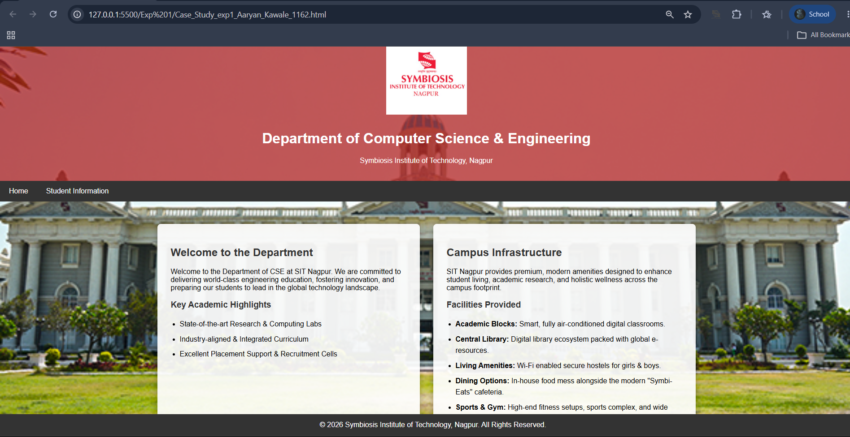
3.Output:

Experiment No. 2

- Experiment Title: Use var,let,const and demonstrate basic festures like template literals and destructing; build a billing calculator with user input.
- Software/Tools Required: VS Code, Html/JS Compiler…
- Experiment Program Code:
- <!DOCTYPE html>
- <html>
- <head>
- <title>Bill Receipt</title>
- <style>
- body {
- background-color: #f4f4f9;
- font-family: Arial, sans-serif;
- display: flex;
- justify-content: center;
- align-items: center;
- height: 100vh;
- margin: 0;
- }
- .receipt-box {
- background-color: #ffffff;
- border: 2px solid #333333;
- padding: 30px;
- width: 350px;
- box-shadow: 0 4px 8px rgba(0, 0, 0, 0.1);
- }
- h3 {
- text-align: center;
- margin-top: 0;
- }
- </style>
- </head>
- <body>

- <script>
- // 1. Popups to take user input
- var uName = prompt("Enter User Name:");
- var contact = prompt("Enter Contact No:");
- var pName = prompt("Enter Product Name:");
- var qty = Number(prompt("Enter Quantity:"));
- var price = Number(prompt("Enter Price per Unit:"));

- // 2. Mathematical calculations
- var total = qty * price;
- var gst = total * 0.18;
- var finalAmount = total + gst;

- // 3. Outputting only the centered bill box
- document.write("<div class='receipt-box'>");
- document.write("<h3>Bill Receipt</h3>");
- document.write("<p><b>User Name:</b> " + uName + "</p>");
- document.write("<p><b>Contact No:</b> " + contact + "</p>");
- document.write("<p><b>Product Name:</b> " + pName + "</p>");
- document.write("<p><b>Quantity:</b> " + qty + "</p>");
- document.write("<p><b>Price:</b> " + price + "</p>");
- document.write("<hr>");
- document.write("<p><b>Total Value:</b> " + total + "</p>");
- document.write("<p><b>GST (18%):</b> " + gst + "</p>");
- document.write("<p style='font-size: 18px;'><b>Final Amount:</b> " + finalAmount + "</p>");
- document.write("<br>");
- document.write("<p style='font-size: 12px; color: #555; text-align: center;'>Name: Aaryan Kawale, PRN: 24070521162</p>");
- document.write("</div>");
- </script>

- </body>
- </html>

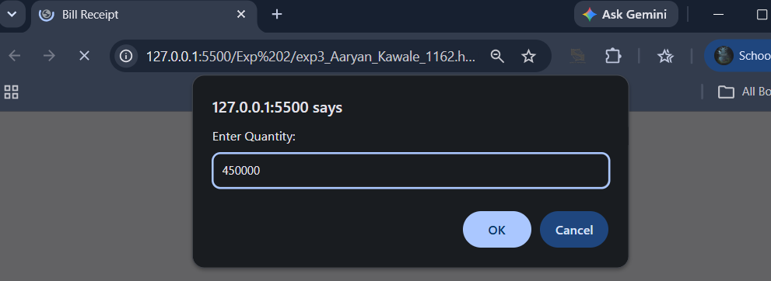
4.Output:

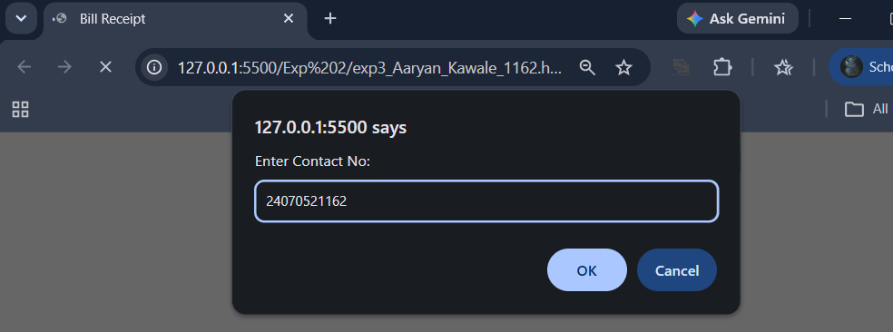
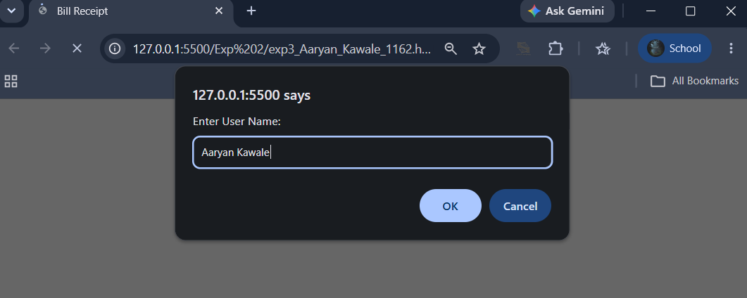

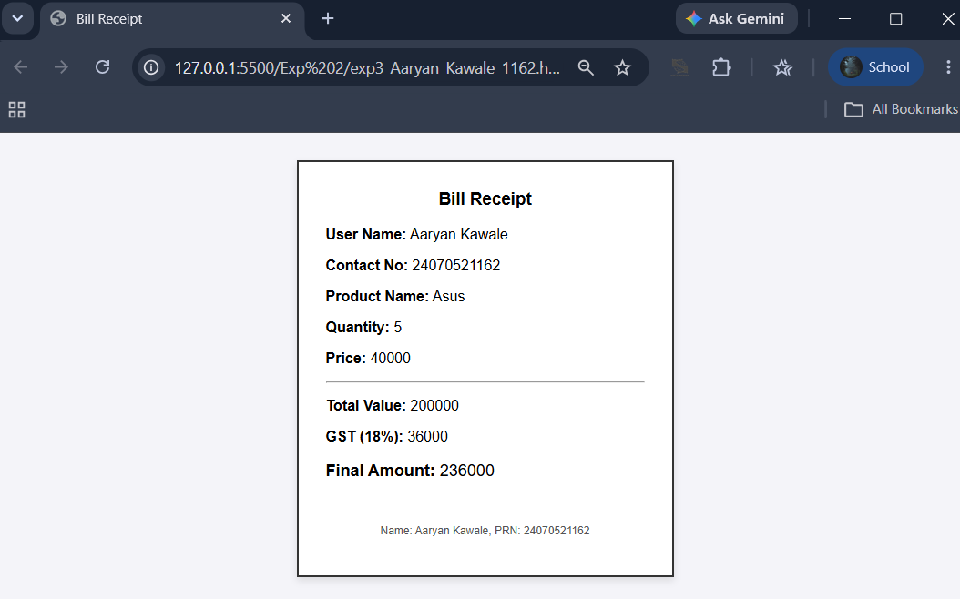

Case Study 2
- Case Study Title: Develop the webpage for an online shopping website using html, css js .

- Case Study Program Code:
- <!DOCTYPE html>
- <html lang="en">
- <head>
- <meta charset="UTF-8">
- <meta name="viewport" content="width=device-width, initial-scale=1.0">
- <title>Simple Shop</title>
- <style>
- * { box-sizing: border-box; margin: 0; padding: 0; font-family: sans-serif; }

- /* Split layout: Left column for items, right column for cart */
- body { display: flex; min-height: 100vh; background: #f4f4f9; }

- .products-section { flex: 2; padding: 20px; }
- .cart-section { flex: 1; padding: 20px; background: #ffffff; border-left: 2px solid #ddd; }

- h2 { margin-bottom: 15px; color: #333; }

- /* Product Grid */
- .grid { display: grid; grid-template-columns: repeat(auto-fill, minmax(180px, 1fr)); gap: 15px; }
- .card { background: #fff; padding: 15px; border-radius: 8px; border: 1px solid #ddd; text-align: center; }
- .card h3 { font-size: 1.1rem; margin-bottom: 5px; }
- .price { color: #2563eb; font-weight: bold; margin-bottom: 10px; }

- button { background: #2563eb; color: white; border: none; padding: 8px 12px; border-radius: 5px; cursor: pointer; }
- button:hover { background: #1d4ed8; }

- /* Cart Table & Summary */
- table { width: 100%; border-collapse: collapse; margin-bottom: 20px; }
- th, td { text-align: left; padding: 8px; border-bottom: 1px solid #eee; }
- .remove-btn { background: #ef4444; padding: 4px 8px; font-size: 0.8rem; }
- .remove-btn:hover { background: #dc2626; }

- .total-box { font-size: 1.2rem; font-weight: bold; display: flex; justify-content: space-between; margin-top: 15px; }
- .checkout-btn { width: 100%; padding: 10px; background: #10b981; margin-top: 15px; font-size: 1rem; }
- .checkout-btn:hover { background: #059669; }
- </style>
- </head>
- <body>

- <!-- LEFT COLUMN: ITEMS -->
- <section class="products-section">
- <h2>Available Items</h2>
- <div class="grid" id="productGrid"></div>
- </section>

- <!-- RIGHT COLUMN: CART & TOTAL -->
- <section class="cart-section">
- <h2>Shopping Cart</h2>
- <table>
- <thead>
- <tr>
- <th>Item</th>
- <th>Qty</th>
- <th>Price</th>
- <th></th>
- </tr>
- </thead>
- <tbody id="cartTable"></tbody>
- </table>

- <div class="total-box">
- <span>Total:</span>
- <span id="grandTotal">₹0.00</span>
- </div>

- <button class="checkout-btn" onclick="checkout()">Checkout</button>
- </section>

- <script>
- // 1. Items Data (Prices in INR)
- const products = [
- { id: 1, name: "Wireless Mouse", price: 1428.00 },
- { id: 2, name: "Keyboard", price: 2856.00 },
- { id: 3, name: "Headphones", price: 4284.00 },
- { id: 4, name: "USB Cable", price: 761.60 }
- ];

- let cart = [];

- // 2. Render Product Cards (Left Column)
- function renderProducts() {
- const grid = document.getElementById("productGrid");
- grid.innerHTML = products.map(p => `
- <div class="card">
- <h3>${p.name}</h3>
- <p class="price">₹${p.price.toFixed(2)}</p>
- <button onclick="addToCart(${p.id})">Add to Cart</button>
- </div>
- `).join('');
- }

- // 3. Add to Cart Logic
- function addToCart(productId) {
- const item = cart.find(i => i.id === productId);
- if (item) {
- item.qty += 1;
- } else {
- const product = products.find(p => p.id === productId);
- cart.push({ ...product, qty: 1 });
- }
- renderCart();
- }

- // 4. Remove from Cart Logic
- function removeFromCart(productId) {
- cart = cart.filter(i => i.id !== productId);
- renderCart();
- }

- // 5. Render Cart Items & Total (Right Column)
- function renderCart() {
- const table = document.getElementById("cartTable");
- const totalEl = document.getElementById("grandTotal");

- if (cart.length === 0) {
- table.innerHTML = `<tr><td colspan="4" style="text-align:center; color:#888;">Cart is empty</td></tr>`;
- totalEl.textContent = "₹0.00";
- return;
- }

- table.innerHTML = cart.map(i => `
- <tr>
- <td>${i.name}</td>
- <td>${i.qty}</td>
- <td>₹${(i.price * i.qty).toFixed(2)}</td>
- <td><button class="remove-btn" onclick="removeFromCart(${i.id})">X</button></td>
- </tr>
- `).join('');

- const total = cart.reduce((sum, item) => sum + (item.price * item.qty), 0);
- totalEl.textContent = `₹${total.toFixed(2)}`;
- }

- function checkout() {
- if (cart.length === 0) return alert("Your cart is empty!");
- alert("Order placed successfully!");
- cart = [];
- renderCart();
- }

- // Initial load
- renderProducts();
- renderCart();
- </script>

- </body>
- </html>

3.Output:
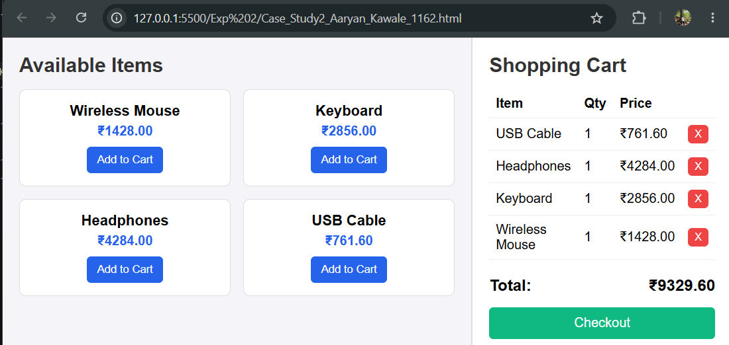

Experiment No. 3

- Experiment Title: Implement control structures and form validations; create a grading system based on user-entered marks.
- Software/Tools Required: VS Code, Html/JS Compiler…
- Experiment Program Code:
- <!DOCTYPE html>
- <html lang="en">
- <head>
- <meta charset="UTF-8">
- <meta name="viewport" content="width=device-width, initial-scale=1.0">
- <title>5-Subject Grading System</title>
- <style>
- * { box-sizing: border-box; font-family: system-ui, -apple-system, sans-serif; }
- body { background-color: #f4f6f9; display: flex; justify-content: center; align-items: center; min-height: 100vh; margin: 0; padding: 1.5rem; }
- .card { background: #ffffff; padding: 2rem; border-radius: 12px; box-shadow: 0 4px 16px rgba(0,0,0,0.08); width: 100%; max-width: 480px; }
- h2 { margin-top: 0; color: #1e293b; text-align: center; }
- .grid { display: grid; grid-template-columns: 1fr 1fr; gap: 0.75rem 1rem; }
- .form-group { margin-bottom: 0.75rem; }
- .full-width { grid-column: span 2; }
- label { display: block; margin-bottom: 0.35rem; font-weight: 600; color: #334155; font-size: 0.9rem; }
- input[type="number"] { width: 100%; padding: 0.65rem; border: 1px solid #cbd5e1; border-radius: 6px; font-size: 0.95rem; }
- input[type="number"]:focus { outline: none; border-color: #2563eb; box-shadow: 0 0 0 3px rgba(37,99,235,0.15); }
- button { width: 100%; padding: 0.75rem; background-color: #2563eb; color: white; border: none; border-radius: 6px; font-size: 1rem; font-weight: 600; cursor: pointer; margin-top: 0.5rem; transition: background 0.2s; }
- button:hover { background-color: #1d4ed8; }
- .error-banner { background-color: #fef2f2; border-left: 4px solid #ef4444; color: #991b1b; padding: 0.75rem; border-radius: 4px; font-size: 0.875rem; margin-bottom: 1rem; display: none; }
- .result-box { margin-top: 1.25rem; padding: 1.25rem; border-radius: 8px; display: none; }
- .result-header { font-size: 1.1rem; font-weight: 700; margin-bottom: 0.5rem; text-align: center; }
- .result-details { font-size: 0.95rem; line-height: 1.5; }
- /* Dynamic Theme Colors */
- .grade-A { background-color: #dcfce7; color: #166534; border: 1px solid #bbf7d0; }
- .grade-B { background-color: #e0f2fe; color: #075985; border: 1px solid #bae6fd; }
- .grade-C { background-color: #fef9c3; color: #854d0e; border: 1px solid #fef08a; }
- .grade-D { background-color: #ffedd5; color: #9a3412; border: 1px solid #fed7aa; }
- .grade-F { background-color: #fee2e2; color: #991b1b; border: 1px solid #fca5a5; }
- </style>
- </head>
- <body>

- <div class="card">
- <h2>Student Assessment</h2>

- <!-- Unified Error Banner -->
- <div id="errorBanner" class="error-banner"></div>

- <form id="gradeForm" novalidate>
- <div class="grid">
- <div class="form-group">
- <label for="sub1">Mathematics</label>
- <input type="number" id="sub1" class="subject-input" placeholder="0 - 100">
- </div>
- <div class="form-group">
- <label for="sub2">Science</label>
- <input type="number" id="sub2" class="subject-input" placeholder="0 - 100">
- </div>
- <div class="form-group">
- <label for="sub3">English</label>
- <input type="number" id="sub3" class="subject-input" placeholder="0 - 100">
- </div>
- <div class="form-group">
- <label for="sub4">History</label>
- <input type="number" id="sub4" class="subject-input" placeholder="0 - 100">
- </div>
- <div class="form-group full-width">
- <label for="sub5">Computer Science</label>
- <input type="number" id="sub5" class="subject-input" placeholder="0 - 100">
- </div>
- </div>
- <button type="submit">Calculate Final Results</button>
- </form>

- <div id="resultBox" class="result-box">
- <div id="resultHeader" class="result-header"></div>
- <div id="resultDetails" class="result-details"></div>
- </div>
- </div>

- <script>
- document.getElementById('gradeForm').addEventListener('submit', function(e) {
- e.preventDefault();

- const inputs = document.querySelectorAll('.subject-input');
- const errorBanner = document.getElementById('errorBanner');
- const resultBox = document.getElementById('resultBox');
- const resultHeader = document.getElementById('resultHeader');
- const resultDetails = document.getElementById('resultDetails');

- // Reset UI state
- errorBanner.style.display = 'none';
- resultBox.style.display = 'none';
- resultBox.className = 'result-box';

- const scores = [];
- let hasFailedSubject = false;

- // --- 1. CONTROL STRUCTURE: Loop with Validation Checks ---
- for (let i = 0; i < inputs.length; i++) {
- const value = inputs[i].value.trim();
- const label = inputs[i].previousElementSibling.textContent;

- // Check empty input
- if (value === '') {
- showError(`Please fill in marks for <strong>${label}</strong>.`);
- inputs[i].focus();
- return;
- }

- const score = Number(value);

- // Check invalid numbers or out-of-bounds inputs
- if (isNaN(score) || score < 0 || score > 100) {
- showError(`Invalid mark for <strong>${label}</strong>. Enter a value between 0 and 100.`);
- inputs[i].focus();
- return;
- }

- // Check for subject failure condition (e.g., passing mark is 40)
- if (score < 40) {
- hasFailedSubject = true;
- }

- scores.push(score);
- }

- // --- 2. CALCULATIONS ---
- const totalMarks = scores.reduce((sum, current) => sum + current, 0);
- const percentage = (totalMarks / (scores.length * 100)) * 100;

- // --- 3. CONTROL STRUCTURE: Grading Logic ---
- let grade = '';
- let status = '';
- let cssClass = '';

- if (hasFailedSubject) {
- // Essential academic condition: Failing any individual subject overrides average grade
- status = 'FAILED (Failed 1 or more subjects)';
- grade = 'F';
- cssClass = 'grade-F';
- } else if (percentage >= 90) {
- status = 'PASSED';
- grade = 'A+ (Outstanding)';
- cssClass = 'grade-A';
- } else if (percentage >= 80) {
- status = 'PASSED';
- grade = 'A (Excellent)';
- cssClass = 'grade-A';
- } else if (percentage >= 70) {
- status = 'PASSED';
- grade = 'B (Good)';
- cssClass = 'grade-B';
- } else if (percentage >= 60) {
- status = 'PASSED';
- grade = 'C (Satisfactory)';
- cssClass = 'grade-C';
- } else if (percentage >= 50) {
- status = 'PASSED';
- grade = 'D (Pass)';
- cssClass = 'grade-D';
- } else {
- status = 'FAILED';
- grade = 'F (Needs Improvement)';
- cssClass = 'grade-F';
- }

- // --- 4. RENDER OUTPUT ---
- resultHeader.textContent = `Status: ${status}`;
- resultDetails.innerHTML = `
- <strong>Total Marks:</strong> ${totalMarks} / 500<br>
- <strong>Overall Percentage:</strong> ${percentage.toFixed(2)}%<br>
- <strong>Final Grade:</strong> ${grade}<br>
- <hr style="margin: 0.75rem 0; border: none; border-top: 1px dashed rgba(0,0,0,0.2);">
- <strong>Student Name:</strong> Aaryan K. Kawale<br>
- <strong>PRN:</strong> 24070521162
- `;

- resultBox.classList.add(cssClass);
- resultBox.style.display = 'block';
- });

- function showError(htmlMessage) {
- const errorBanner = document.getElementById('errorBanner');
- errorBanner.innerHTML = htmlMessage;
- errorBanner.style.display = 'block';
- }
- </script>
- </body>
- </html>

4.Output:

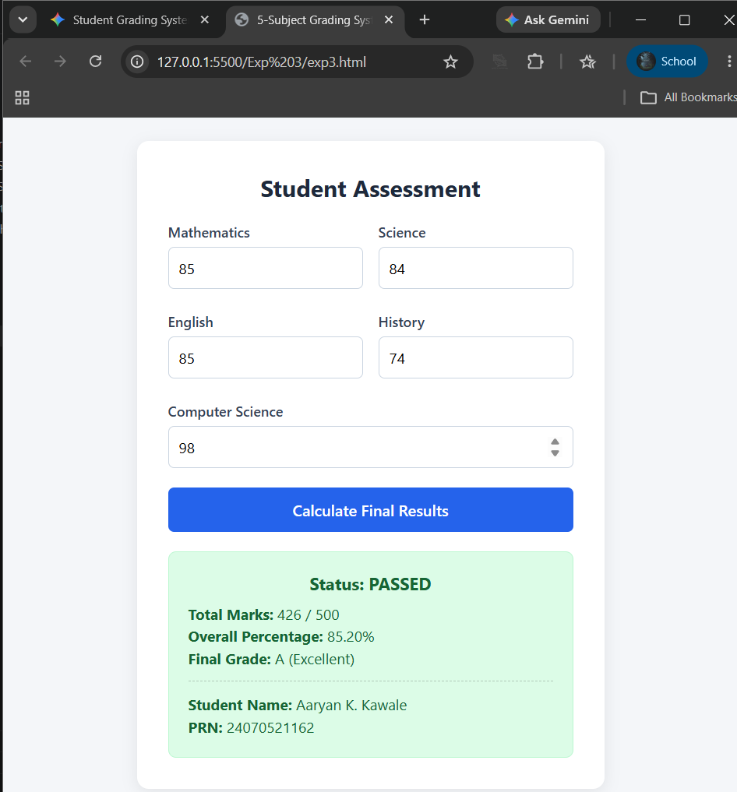

Case Study 3
- Case Study Title: Desing a webpage that match password with the user password, if matched it displays result, if not result not displayed.
- Case Study Program Code:
- <!DOCTYPE html>
- <html lang="en">
- <head>
- <meta charset="UTF-8">
- <meta name="viewport" content="width=device-width, initial-scale=1.0">
- <title>Result Portal</title>
- <style>
- * {
- box-sizing: border-box;
- margin: 0;
- padding: 0;
- font-family: 'Segoe UI', sans-serif;
- }

- body {
- display: flex;
- min-height: 100vh;
- background: #f8fafc;
- }

- /* Split Screen Layout */
- .section-left {
- flex: 1;
- padding: 40px 20px;
- background: #ffffff;
- border-right: 2px solid #e2e8f0;
- display: flex;
- justify-content: center;
- align-items: center;
- }

- .section-right {
- flex: 1;
- padding: 40px 20px;
- display: flex;
- justify-content: center;
- align-items: center;
- }

- /* Form Design */
- .box {
- width: 100%;
- max-width: 320px;
- }

- h2 {
- margin-bottom: 20px;
- color: #0f172a;
- }

- label {
- display: block;
- font-weight: 600;
- margin-bottom: 8px;
- color: #334155;
- }

- input {
- width: 100%;
- padding: 10px 12px;
- border: 1px solid #cbd5e1;
- border-radius: 6px;
- font-size: 16px;
- margin-bottom: 15px;
- outline: none;
- }

- input:focus {
- border-color: #2563eb;
- }

- button {
- width: 100%;
- padding: 10px;
- background: #2563eb;
- color: white;
- border: none;
- border-radius: 6px;
- font-size: 16px;
- font-weight: 600;
- cursor: pointer;
- }

- button:hover {
- background: #1d4ed8;
- }

- .error {
- color: #dc2626;
- background: #fef2f2;
- border: 1px solid #fecaca;
- padding: 8px;
- border-radius: 6px;
- margin-top: 12px;
- display: none;
- text-align: center;
- font-size: 14px;
- }

- /* Result Card Design */
- .placeholder {
- color: #64748b;
- font-size: 16px;
- }

- .result-card {
- display: none;
- background: white;
- border: 2px solid #10b981;
- border-radius: 12px;
- padding: 30px;
- text-align: center;
- box-shadow: 0 4px 6px -1px rgba(0, 0, 0, 0.1);
- width: 260px;
- }

- .status {
- background: #d1fae5;
- color: #065f46;
- padding: 4px 12px;
- border-radius: 12px;
- font-weight: bold;
- font-size: 14px;
- display: inline-block;
- margin-bottom: 15px;
- }

- .gpa {
- font-size: 48px;
- font-weight: 800;
- color: #2563eb;
- }

- .label {
- color: #64748b;
- font-size: 14px;
- font-weight: 600;
- }
- </style>
- </head>
- <body>

- <!-- LEFT COLUMN: PASSWORD INPUT -->
- <div class="section-left">
- <div class="box">
- <h2>Student Login</h2>
- <form id="loginForm">
- <label for="passInput">Password</label>
- <!-- type="text" की वजह से पासवर्ड टाइप करते वक्त दिखता रहेगा -->
- <input type="text" id="passInput" placeholder="Enter password..." required autocomplete="off">
- <button type="submit">Submit</button>
- </form>
- <div id="errorMsg" class="error">Incorrect Password!</div>
- </div>
- </div>

- <!-- RIGHT COLUMN: RESULT DISPLAY -->
- <div class="section-right">
- <div id="placeholder" class="placeholder">🔒 Enter correct password to view result</div>

- <div id="resultCard" class="result-card">
- <span class="status">Pass</span>
- <div class="gpa">9</div>
- <div class="label">GPA</div>
- </div>
- </div>

- <!-- JAVASCRIPT -->
- <script>
- const TARGET_PASS = "Aaryan1162";

- document.getElementById("loginForm").addEventListener("submit", function(e) {
- e.preventDefault();
- const inputVal = document.getElementById("passInput").value.trim();

- const isCorrect = (inputVal === TARGET_PASS);

- document.getElementById("errorMsg").style.display = isCorrect ? "none" : "block";
- document.getElementById("resultCard").style.display = isCorrect ? "block" : "none";
- document.getElementById("placeholder").style.display = isCorrect ? "none" : "block";
- });
- </script>

- </body>
- </html>

3.Output:

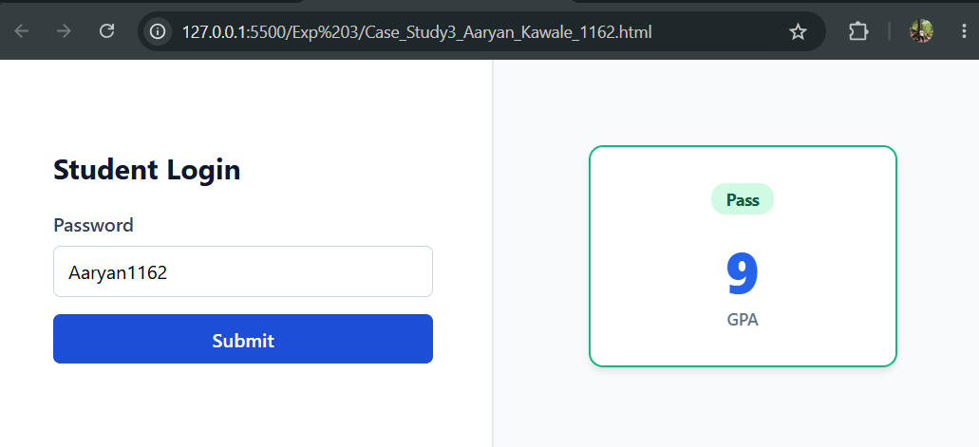

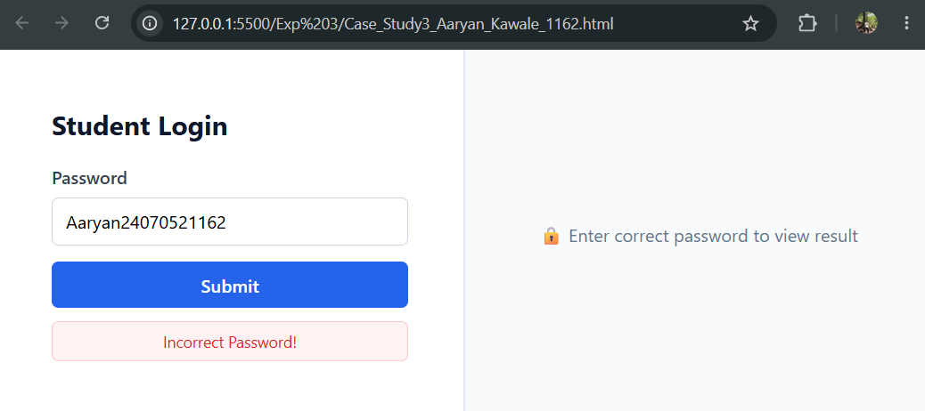

Experiment No. 4

- Experiment Title: Use Function types, scope, and closures; apply try and catch; build a palindrome checker.
- Software/Tools Required: VS Code, Html/JS Compiler…
- Experiment Program Code:
- <!DOCTYPE html>
- <html lang="en">
- <head>
- <meta charset="UTF-8">
- <meta name="viewport" content="width=device-width, initial-scale=1.0">
- <title>Palindrome Checker</title>
- <style>
- :root {
- --bg-color: #f4f6f8;
- --card-bg: #ffffff;
- --primary: #4f46e5;
- --primary-hover: #4338ca;
- --text-main: #1f2937;
- --text-muted: #6b7280;
- --success-bg: #d1fae5;
- --success-text: #065f46;
- --error-bg: #fee2e2;
- --error-text: #991b1b;
- }

- * {
- box-sizing: border-box;
- margin: 0;
- padding: 0;
- font-family: -apple-system, BlinkMacSystemFont, "Segoe UI", Roboto, Helvetica, Arial, sans-serif;
- }

- body {
- background-color: var(--bg-color);
- color: var(--text-main);
- display: flex;
- justify-content: center;
- align-items: center;
- min-height: 100vh;
- padding: 20px;
- }

- .container {
- background-color: var(--card-bg);
- padding: 32px;
- border-radius: 12px;
- box-shadow: 0 10px 15px -3px rgba(0, 0, 0, 0.1), 0 4px 6px -2px rgba(0, 0, 0, 0.05);
- width: 100%;
- max-width: 480px;
- }

- h1 {
- font-size: 1.5rem;
- margin-bottom: 8px;
- color: var(--text-main);
- text-align: center;
- }

- p.subtitle {
- font-size: 0.9rem;
- color: var(--text-muted);
- text-align: center;
- margin-bottom: 24px;
- }

- .input-group {
- display: flex;
- flex-direction: column;
- gap: 12px;
- }

- input[type="text"] {
- width: 100%;
- padding: 12px 16px;
- font-size: 1rem;
- border: 2px solid #e5e7eb;
- border-radius: 8px;
- outline: none;
- transition: border-color 0.2s;
- }

- input[type="text"]:focus {
- border-color: var(--primary);
- }

- button {
- width: 100%;
- padding: 12px;
- font-size: 1rem;
- font-weight: 600;
- color: #ffffff;
- background-color: var(--primary);
- border: none;
- border-radius: 8px;
- cursor: pointer;
- transition: background-color 0.2s;
- }

- button:hover {
- background-color: var(--primary-hover);
- }

- #result {
- margin-top: 20px;
- padding: 12px 16px;
- border-radius: 8px;
- font-size: 0.95rem;
- text-align: center;
- display: none;
- word-break: break-word;
- }

- #result.success {
- display: block;
- background-color: var(--success-bg);
- color: var(--success-text);
- }

- #result.error {
- display: block;
- background-color: var(--error-bg);
- color: var(--error-text);
- }
- </style>
- </head>
- <body>

- <div class="container">
- <h1>Palindrome Checker</h1>
- <p class="subtitle">Enter a word, number, or phrase to test</p>

- <div class="input-group">
- <input type="text" id="userInput" placeholder="e.g., racecar, 12321, or A man, a plan..." />
- <button onclick="checkPalindrome()">Check</button>
- </div>

- <div id="result"></div>
- </div>

- <script>
- function checkPalindrome() {
- const inputElement = document.getElementById("userInput");
- const resultElement = document.getElementById("result");
- const rawText = inputElement.value;

- if (!rawText.trim()) {
- resultElement.className = "error";
- resultElement.textContent = "Please enter something to check!";
- return;
- }

- // Clean the string: remove non-alphanumeric characters and convert to lowercase
- const cleaned = rawText.toLowerCase().replace(/[^a-z0-9]/g, "");

- // Reverse the cleaned string
- const reversed = cleaned.split("").reverse().join("");

- // Compare cleaned string with its reversed counterpart
- if (cleaned === reversed) {
- resultElement.className = "success";
- resultElement.innerHTML = `<strong>"${rawText}"</strong> is a palindrome!`;
- } else {
- resultElement.className = "error";
- resultElement.innerHTML = `<strong>"${rawText}"</strong> is NOT a palindrome.`;
- }
- }

- // Allow pressing "Enter" key to trigger the check
- document.getElementById("userInput").addEventListener("keypress", function(event) {
- if (event.key === "Enter") {
- checkPalindrome();
- }
- });
- </script>

- </body>
- </html>

4.Output;
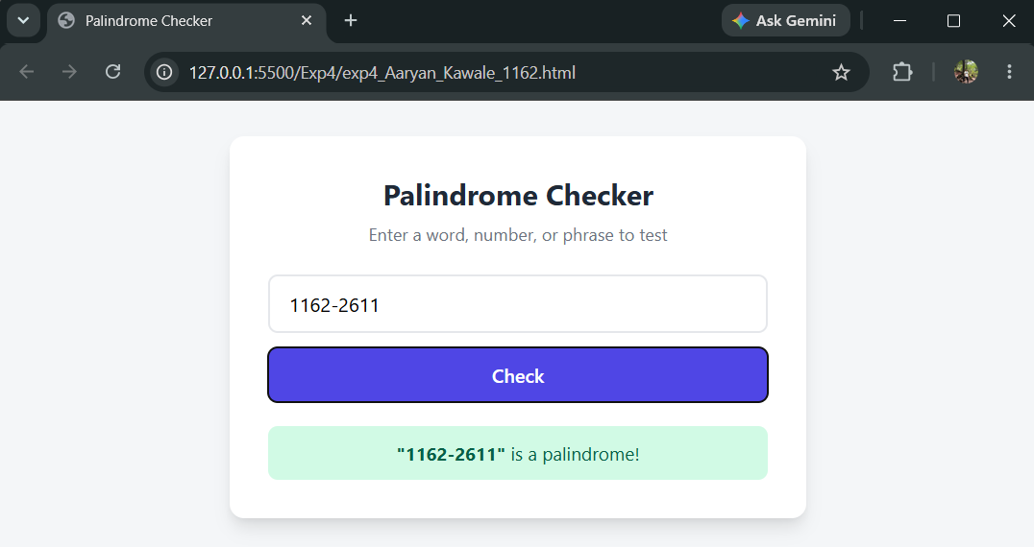

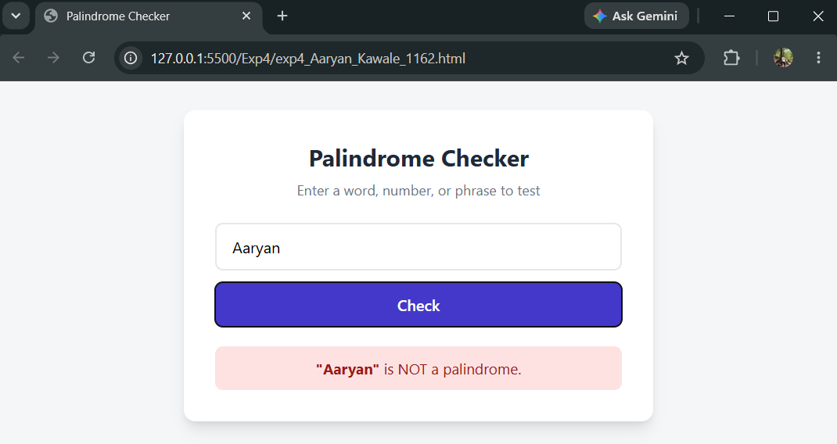

Case Study 4
- Case Study Title: Desing a webpage to check whether the password is Palindrome or not if Palindrome display msg Weak Pass if not display Strong Pass.
- Case Study Program Code:
- <!DOCTYPE html>
- <html lang="en">
- <head>
- <meta charset="UTF-8">
- <meta name="viewport" content="width=device-width, initial-scale=1.0">
- <title>Password Palindrome & Strength Checker</title>
- <style>
- :root {
- --bg-color: #0f172a;
- --card-bg: #1e293b;
- --primary: #6366f1;
- --primary-hover: #4f46e5;
- --text-main: #f8fafc;
- --text-muted: #94a3b8;
- --warning-bg: #451a03;
- --warning-text: #fde047;
- --warning-border: #854d0e;
- --success-bg: #064e3b;
- --success-text: #6ee7b7;
- --success-border: #047857;
- --error-bg: #450a0a;
- --error-text: #fca5a5;
- --error-border: #991b1b;
- }

- * {
- box-sizing: border-box;
- margin: 0;
- padding: 0;
- font-family: -apple-system, BlinkMacSystemFont, "Segoe UI", Roboto, Helvetica, Arial, sans-serif;
- }

- body {
- background-color: var(--bg-color);
- color: var(--text-main);
- display: flex;
- justify-content: center;
- align-items: center;
- min-height: 100vh;
- padding: 20px;
- }

- .container {
- background-color: var(--card-bg);
- padding: 32px;
- border-radius: 12px;
- box-shadow: 0 10px 25px -5px rgba(0, 0, 0, 0.5);
- width: 100%;
- max-width: 480px;
- border: 1px solid #334155;
- }

- h1 {
- font-size: 1.5rem;
- margin-bottom: 8px;
- color: var(--text-main);
- text-align: center;
- }

- p.subtitle {
- font-size: 0.9rem;
- color: var(--text-muted);
- text-align: center;
- margin-bottom: 24px;
- }

- .input-group {
- display: flex;
- flex-direction: column;
- gap: 12px;
- }

- .password-wrapper {
- position: relative;
- width: 100%;
- display: flex;
- align-items: center;
- }

- input[type="text"] {
- width: 100%;
- padding: 12px 60px 12px 16px;
- font-size: 1.1rem;
- letter-spacing: 1px;
- background-color: #0f172a;
- color: var(--text-main);
- border: 2px solid #334155;
- border-radius: 8px;
- outline: none;
- transition: border-color 0.2s;
- }

- input:focus {
- border-color: var(--primary);
- }

- .toggle-btn {
- position: absolute;
- right: 12px;
- background: none;
- border: none;
- color: var(--text-muted);
- cursor: pointer;
- font-size: 0.85rem;
- padding: 4px 8px;
- border-radius: 4px;
- width: auto;
- }

- .toggle-btn:hover {
- color: var(--text-main);
- background-color: transparent;
- }

- button.btn-submit {
- width: 100%;
- padding: 12px;
- font-size: 1rem;
- font-weight: 600;
- color: #ffffff;
- background-color: var(--primary);
- border: none;
- border-radius: 8px;
- cursor: pointer;
- transition: background-color 0.2s;
- }

- button.btn-submit:hover {
- background-color: var(--primary-hover);
- }

- #result {
- margin-top: 20px;
- padding: 14px 16px;
- border-radius: 8px;
- font-size: 0.95rem;
- text-align: center;
- display: none;
- word-break: break-word;
- border: 1px solid transparent;
- }

- #result.warning {
- display: block;
- background-color: var(--warning-bg);
- color: var(--warning-text);
- border-color: var(--warning-border);
- }

- #result.success {
- display: block;
- background-color: var(--success-bg);
- color: var(--success-text);
- border-color: var(--success-border);
- }

- #result.error {
- display: block;
- background-color: var(--error-bg);
- color: var(--error-text);
- border-color: var(--error-border);
- }
- </style>
- </head>
- <body>

- <div class="container">
- <h1>Password Security Checker</h1>
- <p class="subtitle">Check if your password is a vulnerable palindrome</p>

- <div class="input-group">
- <div class="password-wrapper">
- <input type="text" id="passwordInput" placeholder="Enter password..." />
- <button type="button" class="toggle-btn" id="toggleBtn" onclick="toggleVisibility()">Hide</button>
- </div>
- <button class="btn-submit" onclick="checkPassword()">Check Password</button>
- </div>

- <div id="result"></div>
- </div>

- <script>
- let actualPassword = "";
- let isHidden = false;

- const inputElement = document.getElementById("passwordInput");

- // Intercept input changes to support custom asterisk masking
- inputElement.addEventListener("input", function(e) {
- if (isHidden) {
- // If characters were added or deleted
- const diff = e.target.value.length - actualPassword.length;

- if (diff > 0) {
- // Characters added
- const addedChars = e.target.value.slice(actualPassword.length);
- actualPassword += addedChars;
- } else if (diff < 0) {
- // Characters removed (Backspace)
- actualPassword = actualPassword.slice(0, e.target.value.length);
- }

- // Render asterisks in the input display
- inputElement.value = "*".repeat(actualPassword.length);
- } else {
- actualPassword = e.target.value;
- }
- });

- function toggleVisibility() {
- const btn = document.getElementById("toggleBtn");

- if (!isHidden) {
- // Switch to Hidden mode -> replace characters with *
- isHidden = true;
- inputElement.value = "*".repeat(actualPassword.length);
- btn.textContent = "Show";
- } else {
- // Switch to Visible mode -> show raw password
- isHidden = false;
- inputElement.value = actualPassword;
- btn.textContent = "Hide";
- }
- }

- function checkPassword() {
- const resultElement = document.getElementById("result");
- const password = actualPassword;

- if (!password) {
- resultElement.className = "error";
- resultElement.textContent = "Please enter a password first!";
- return;
- }

- // Reverse exact password
- const reversedPassword = password.split("").reverse().join("");

- // Check if exact palindrome
- if (password === reversedPassword) {
- resultElement.className = "warning";
- resultElement.innerHTML = "⚠️ <strong>Weak password!</strong> It is a palindrome. Choose a strong password.";
- } else {
- resultElement.className = "success";
- resultElement.innerHTML = "🔒 <strong>It is a strong non-palindrome password.</strong>";
- }
- }

- // Trigger check on Enter key press
- inputElement.addEventListener("keypress", function(event) {
- if (event.key === "Enter") {
- checkPassword();
- }
- });
- </script>

- </body>
- </html>

3.Output:

